Final ( 2022-2023)
01. A.
i) Show the output of the following code:
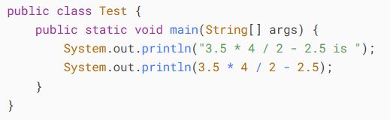
ii) Identify and fix the errors in the following code:
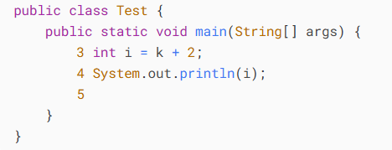
iii) What are syntax errors (compile errors), runtime errors, and logic errors?
iv) Analyze the following code. Is count < 100 always true, always false, or sometimes true or sometimes false at Point A, Point B, and Point C?
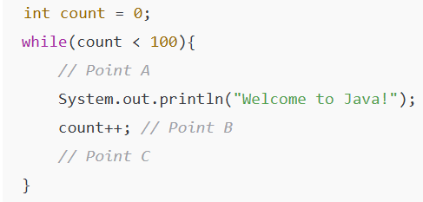
v) How many times are the following loop bodies repeated? What is the output of each loop?
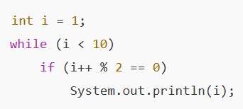
vi) Count the number of iterations in the following loops.
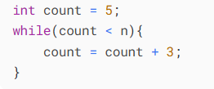
vii) What is wrong in the following code?
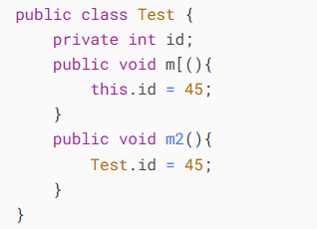
viii) Write the output of the following code:
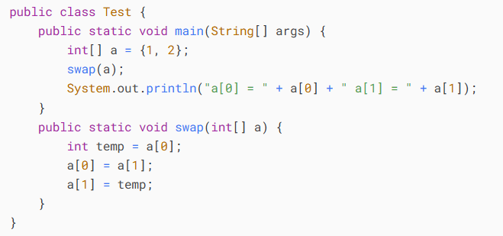
ix) What is the output of the following code?
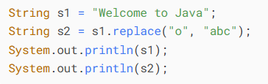
x) Convert the following for loop statement to a while loop and to a do-while loop:
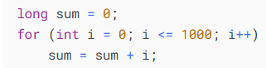
xi) Write four different Java statements that each add 1 to integer variable x and subtract 1 to integer variable y;
xii) How many times is the println statement executed?
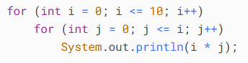
xiii) What is wrong with the following while statement?
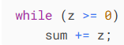
xiv) Find the error in each of the following program segments. Explain how to correct the error.
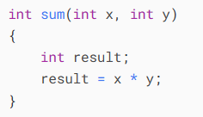

Sol^{n}:
- 3.5 * 4 / 2 - 2.5 is
4.5
- Uninitialized k. Fixed: int k = any integer value.
- • Syntax errors (compile errors): Errors in Java syntax that prevent compilation. Example: missing ; or using undeclared variables.
• Runtime errors: Errors that occur while program is running. Example: division by zero, accessing invalid array index.
• Logic errors: Program compiles and runs, but output is incorrect due to wrong logic. Example: using + instead of *.
- .
- Number of loop executions: 9 times
Output:
3
5
7
9
- .
- id is an instance variable, not a static variable.
You cannot access it using the class name (Test.id) — only static variables can be accessed that way.
If we want id to be shared by all objects:
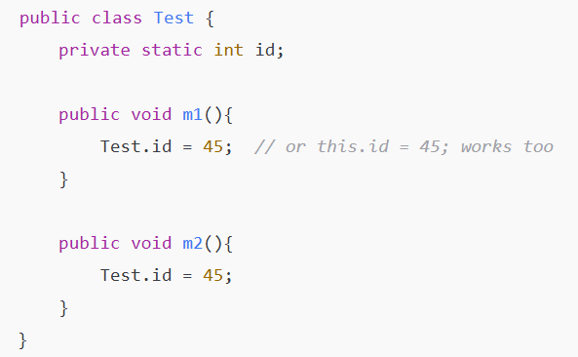
- a[0] = 2 a[1] = 1
- Welcome to Java
Welcabcme tabc Java
- Convert for → while & do-while
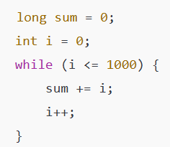
Do-while loop:
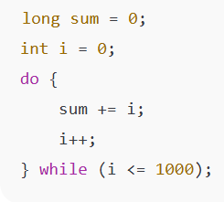

- 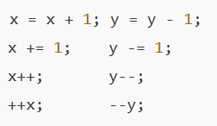
- Total executions = 1 + 2 + 3 + ... + 11 = 66 times.
- infinite loop and uninitialized sum, z.
- Missing return statement.
Fix code:
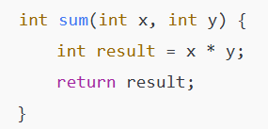

02. A.
What data types are required for a switch variable?
If the keyword break is not used after a case is processed, what is the next statement to be executed?
Can you convert a switch statement to an equivalent if statement, or vice versa?
What are the advantages of using a switch statement? (2 marks)
Sol^{n}:
Data types for switch variable: byte, short, char, int, String, enum.
If the keyword break is not used after a case is proceed, Execution falls through to the next case.
Yes. A switch can be rewritten as if-else if, and an if-else if chain can be rewritten as a switch if it checks a single variable for constant values.
Advantages:
- Easier to read than multiple if-else for many conditions.
- Can be more efficient in execution.

02. B.
What is method overloading?
Is it permissible to define two methods that have the same name but different parameter types?
Is it permissible to define two methods in a class that have identical method names and parameter lists but different return value types or different modifiers? (2 marks)
Sol^{n}:
Method overloading in Java is a feature that allows a class to have more than one method with the same name but different parameter lists (different number of parameters, different data types, or both).
Yes, two methods with the same name but different parameter types are allowed (this is valid overloading).
Two methods with identical names and parameter lists but only different return types or modifiers are not allowed (compiler error, as method signature becomes the same).

02. C.
Can we overload the constructors? Explain with example. (3 marks)
Sol^{n}:
Yes, we can overload constructors in Java.
Constructor overloading means defining multiple constructors in the same class with the same name (class name) but with different parameter lists (different number or types of arguments).
This allows us to create objects in different ways depending on the given arguments.
Example:
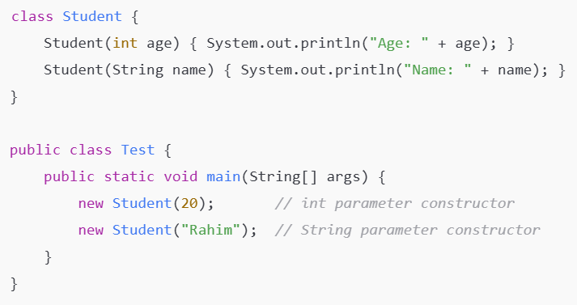

02. D.
Creating a Hello World Example and write the meaning of class, public, static, void, main, String[], System.out.println(). (3 marks)
Sol^{n}:
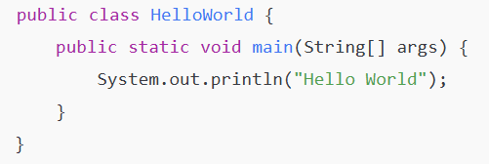
Meaning of:
class → Used to define a class, which is a blueprint for objects. Here, HelloWorld is the class name. (keyword / class declaration)
public → An access modifier that makes the class or method accessible from anywhere. (access modifier)
static → Means the method belongs to the class itself, not to any object of the class. (modifier / keyword) [A keyword that indicates a method or variable belongs to the class itself, rather than to any specific object (instance) created from the class. This means you can use it without creating an object of the class.]
void → Indicates that the method does not return any value. (return type / keyword)
main → The entry point of the program. Java starts execution from the main method. (method name)
String[] args → Represents command-line arguments passed to the program as an array of Strings. (data type + variable)
System.out.println() → Prints the specified message to the console and moves to a new line. (method call)

02. E.
Write a Java program to create a class called "Employee" with a name, job title, and salary attributes, and methods to calculate and update salary. (4 marks)
Sol^{n}:
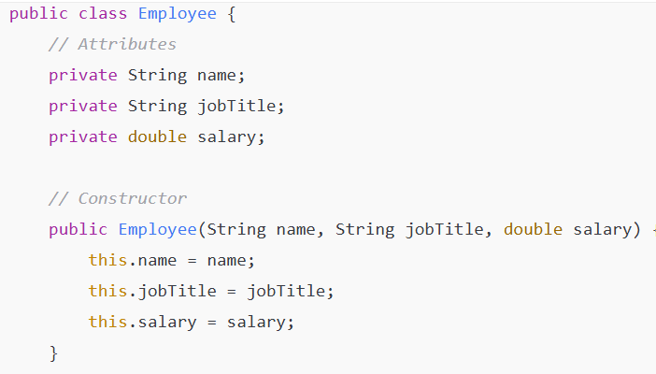
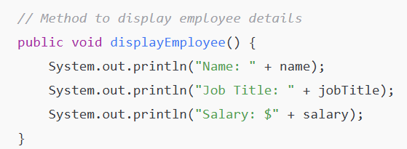
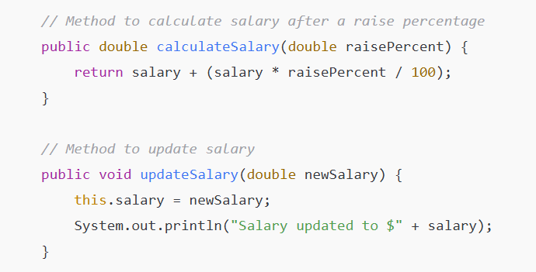
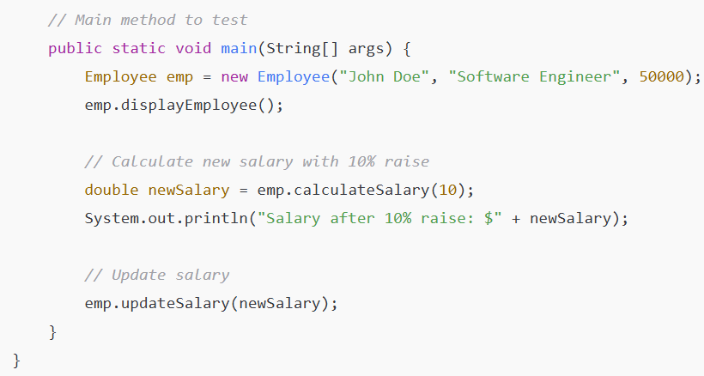
Output:
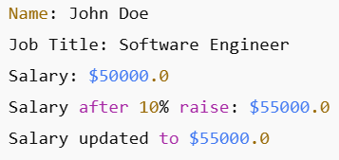

03. A.
Justify the statements "parameters (formal arguments) and instance variables are same So, we are using this keyword to distinguish local variable and instance variable". (3 marks)
Sol^{n}:
Parameters (formal arguments) and instance variables can have identical names within a class. When a local variable (including a parameter) has the same name as an instance variable, the local variable takes precedence inside the method or constructor. To access the instance variable explicitly and avoid ambiguity, the this keyword is used. Therefore, this distinguishes instance variables from local variables or parameters that share the same name.

03. B.
Write concept of object initialization through a constructor with an example. (3 marks)
Sol^{n}:
In Java, a constructor is a special method that is used to initialize objects of a class. When an object is created, the constructor is called automatically to assign initial values to the instance variables. The constructor has the same name as the class and does not have a return type, not even void.
Thus, a constructor provides a convenient way to initialize an object’s state at the time of its creation.
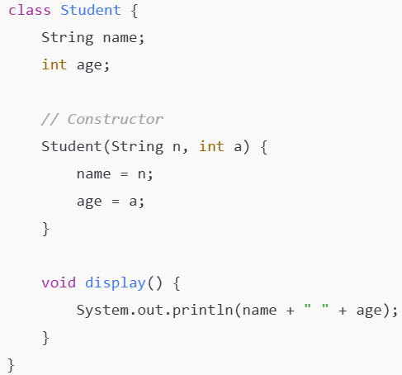
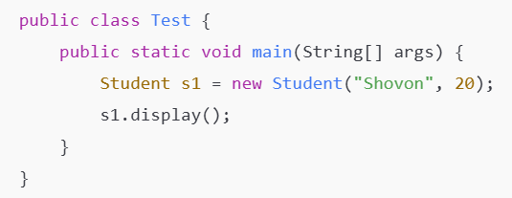

03. C.
Define Static variable. Write a Program of Counter by Static Variable. (3 marks)
Sol^{n}:
A static variable in Java (or similar object-oriented languages) is a class-level variable that is shared among all objects of the class. Unlike instance variables, which are unique to each object, a static variable has a single copy in memory, no matter how many objects of the class are created. 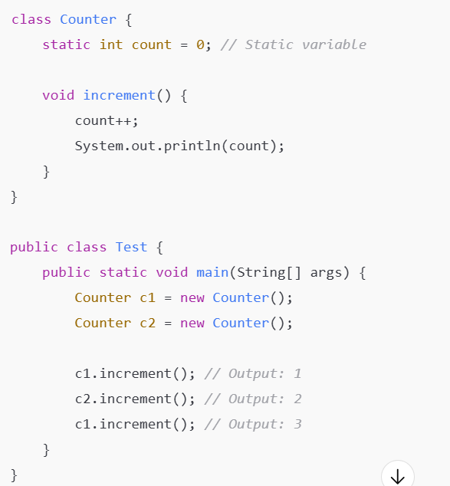
03. D.
Fill in the blanks:
a) ________ is a form of software reusability in which new classes acquire the members of existing classes and embellish those classes with new capabilities.
b) In single inheritance, a class exists in a(n) ________ relationship with its subclasses.
c) The public methods of a class are also known as the class's ________ or ________.
d) Get methods are commonly called ________ or ________.
e) Keyword ________ specifies that a variable is not modifiable after initialization in a declaration or constructor.
f) Typically, ________ statements are used for counter-controlled repetition and ________ statements for sentinel-controlled repetition.
g) The ________ operator can be used to ensure that two conditions are both true before choosing a certain path of execution.
h) If the increment operator is ________ to a variable, first the variable is incremented by 1, then its new value is used in the expression.
i) Return type ________ indicates that a method will not return a value.
j) Keyword public is an access ________.
Sol^{n}:
a) Inheritance is a form of software reusability in which new classes acquire the members of existing classes and embellish those classes with new capabilities.
b) In single inheritance, a class exists in a(n) “Is-a” relationship with its subclasses.
c) The public methods of a class are also known as the class's interface or services.
d) Get methods are commonly called accessors or getter methods.
e) Keyword final specifies that a variable is not modifiable after initialization in a declaration or constructor.
f) Typically, for statements are used for counter-controlled repetition and while statements for sentinel-controlled repetition.
g) The && operator can be used to ensure that two conditions are both true before choosing a certain path of execution.
h) If the increment operator is prefix (++var) to a variable, first the variable is incremented by 1, then its new value is used in the expression.
i) Return type void indicates that a method will not return a value.
j) Keyword public is an access modifier.

04. A.
How does method overriding demonstrate runtime polymorphism in Java? (3 marks)
Sol^{n}:
Method overriding occurs when a subclass provides its own implementation of a method that is already defined in its superclass. It demonstrates runtime polymorphism because the method that gets executed is determined at runtime, depending on the actual object type, not the reference type.
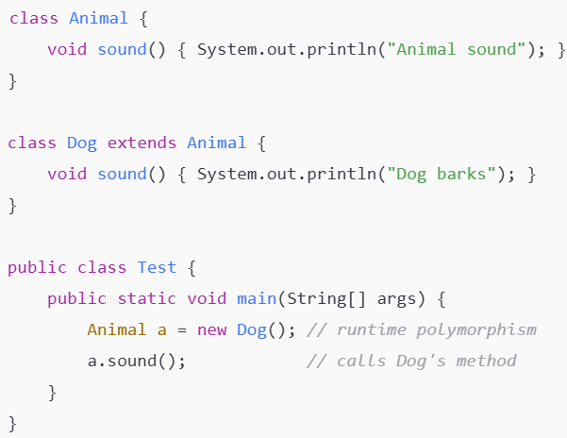
Explanation:
- The reference type is Animal, but the actual object is Dog.
- At runtime, Java checks the actual object and calls the overridden sound() method in Dog.
- This behavior is called runtime polymorphism because the method executed depends on the object type during execution, not the reference type.

04. B.
Explain the impact of thread priorities in multithreading. (3 marks)
Sol^{n}:
In multithreading, each thread is assigned a priority (an integer value from 1 to 10 in Java) which helps the Thread Scheduler decide the order in which threads are executed.
Impact of thread priorities:
- Higher-priority threads get preference – The Thread Scheduler usually gives more CPU time to threads with higher priority than lower-priority ones.
- Affects execution order – If multiple threads are ready to run, the one with the highest priority is likely to run first.
- Does not guarantee order – Thread priority only provides a hint to the scheduler; actual execution still depends on the operating system’s scheduling policy.
Example:
class MyThread extends Thread {
public void run() {
System.out.println(getName() + " running with priority " + getPriority());
}

public static void main(String[] args) {
Thread t = new MyThread();
t1.setPriority(Thread.MIN_PRIORITY); // Priority 1
t2.setPriority(Thread.MAX_PRIORITY); // Priority 10
t.setPriority(7); // Set priority 7
t.start();
}
}

04. C. Can we instantiate an abstract class in Java? Why or why not? (2 marks)
Sol^{n}:
No, we cannot instantiate an abstract class in Java because it may contain abstract methods (methods without implementation).
Since abstract classes are incomplete by design, Java does not allow creating objects of them directly.
Example:
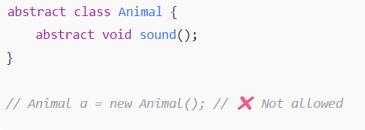
Instead, we must create a subclass that provides implementations for all abstract methods and instantiate that subclass.

04. D. What happens when a class inherits from multiple classes in Java? (2 marks)
Sol^{n}:
In Java, a class cannot inherit from multiple classes directly. This is called multiple inheritance, and Java does not allow it to avoid ambiguity and conflicts (like the "diamond problem").
However, a class can implement multiple interfaces, which allows a form of multiple inheritance for behavior (methods) but not state (instance variables).
04. E. How do getter and setter methods work in encapsulation? (2 marks)
Sol^{n}:
Getter and setter methods are used in encapsulation to control access to private class variables.
- Getter methods allow reading (accessing) private data.
- Setter methods allow modifying private data in a controlled way.
Example:
1  2  3  4  5  6  7  8  9  10  11 | class Student {  private int age; // private variable  public int getAge() { // getter  return age;  }  public void setAge(int a) { // setter  if (a > 0) age = a; // validation  }  }

➡️ This protects data by preventing direct access and allowing validation before changing values.

04. E. What is the difference between Exception and Error in Java? (2 marks)
Sol^{n}:
Difference between Exception and Error in Java:
Aspect | Exception | Error
Meaning | Problems that occur during program execution. | Serious problems that occur outside the program’s control.
Handle | Can be handled by the program. | Cannot be handled easily.
Examples | NullPointerException, IOException | OutOfMemoryError, StackOverflowError
05. A. Explain the role of the try, catch, finally, and throw keywords in Java. (4 marks)
Sol^{n}:
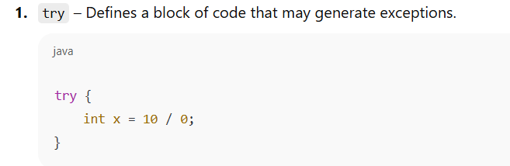
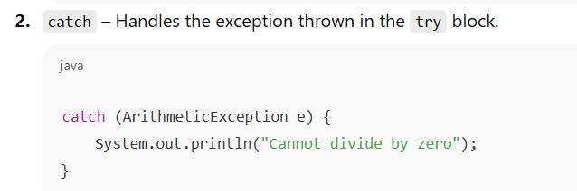
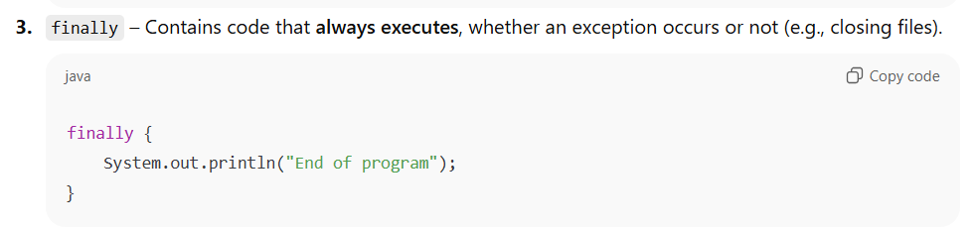
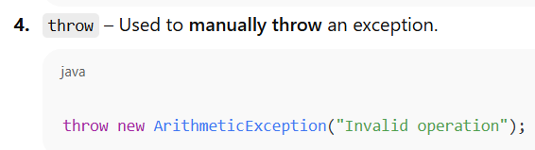

05. B. How can you create a thread in Java? Provide examples using both the Thread class and the Runnable interface. (4 marks)
Sol^{n}:
ChatGPT said:
Two ways to create a thread in Java:
1. By extending the Thread class
2. By implementing the Runnable interface

Example: By extending the Thread class
1  2  3  4  5  6  7  8  9  10  11  12 | class MyThread extends Thread {  public void run() { // thread code  System.out.println("Thread running using Thread class");  }  }  public class Main {  public static void main(String[] args) {  MyThread t = new MyThread();  t.start(); // start the thread

Example: By implementing the Runnable interface
1  2  3  4  5  6  7  8  9  10  11  12 | class MyRunnable implements Runnable {  public void run() {  System.out.println("Thread running using Runnable interface");  }  }  public class Main {  public static void main(String[] args) {  Thread t = new Thread(new MyRunnable());  t.start();  }  }

05. C. How does covariant return type work with method overriding in Java? Provide an example. (4 marks)
Sol^{n}:
In Java method overriding, a covariant return type means that the overriding method in the subclass can return a subtype of the object returned by the superclass method.
This allows more specific return types without breaking polymorphism.
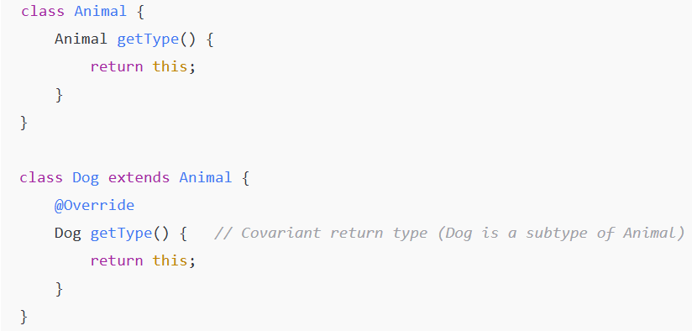
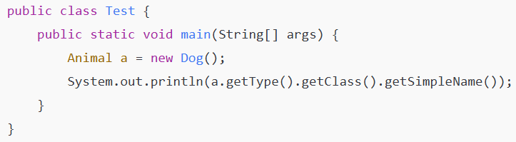
✦ Explanation:
- In Animal, getType() returns Animal.
- In Dog, the overridden getType() returns Dog (a subclass of Animal).
- This is valid because of covariant return types, allowing more specific return values while preserving overriding rules.

05. D. What is aggregation in Java, and how does it differ from inheritance? (2 marks)
Sol^{n}:
Aggregation is a “has-a” relationship where one class contains a reference to another class as a member. It represents a whole-part relationship, but the contained object can exist independently of the container.
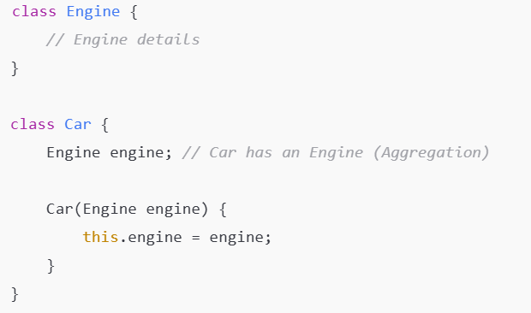
Relationship: Aggregation is a whole-part relationship, whereas inheritance is a parent-child relationship.
Object Independence: In aggregation, the part (contained object) can exist independently. In inheritance, the subclass depends on the superclass.
Keyword in Java: Aggregation does not use a special keyword; inheritance uses extends.

06. A. Mid than check
Sol^{n}:
Mid then write answer.

06. B. Explain how exception propagation works when a method calls another method that throws an exception. (4 marks)
Sol^{n}:
Mid then write answer.

06. C. What happens when a subclass overrides a method from a superclass, and the superclass method is called on the subclass instance? (3 marks)
Sol^{n}:
When a subclass overrides a method from a superclass and the superclass method is called on a subclass instance, the overridden method in the subclass is executed, not the superclass method.
This happens because Java uses runtime polymorphism (dynamic method dispatch) to determine which method to execute based on the actual object type, not the reference type.
Example:
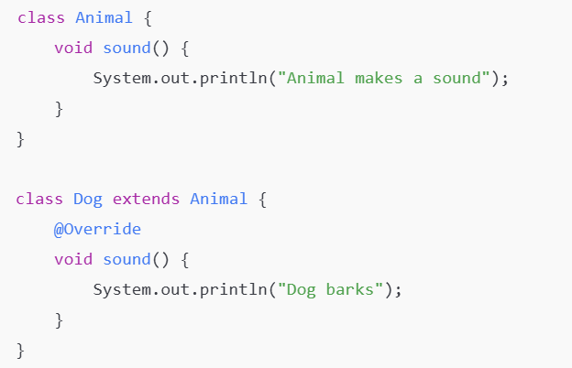
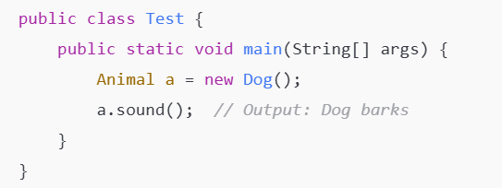
Explanation:
- a is a reference of type Animal but points to a Dog object.
- At runtime, Java calls Dog’s sound() method because the actual object is a Dog.

06. D. Can a method with a more restrictive access modifier override a method with a less restrictive one? Explain with an example. (3 marks)
Sol^{n}:
No, a method with a more restrictive access modifier cannot override a method with a less restrictive one in Java. This is because overriding methods must be at least as accessible as the method they override, otherwise the subclass would prevent access that the superclass allows, breaking polymorphism.
Example:
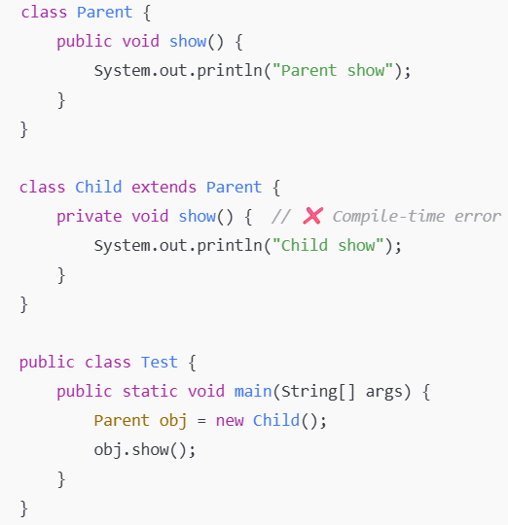
Explanation:
- Parent method show() is public → accessible everywhere.
- Child tries to override it as private → more restrictive.
- Java does not allow this, because it would break polymorphism:
Parent obj = new Child();
obj.show(); // Should be allowed, but Child's private method is inaccessible
- Rule: Overriding method must be same or less restrictive.
So private in subclass cannot override a public method in superclass.

